Project Mastery Assignment
Error log
Stefan S
CSE 2140 2nd Language Programming
(Project.java)
Describe the errors you’ve encountered while working on this assignment. What caused the error and how do you overcome the error?
Logic Error: I declare these variables as integers, and as a result end up doing integer division
In order to make sure I’m doing real division, I declare all of the starting variables to be doubles. This is because I’m storing the result of my real division back into my starting variables. If I was storing them to a different variable, I’d use typecasting instead.
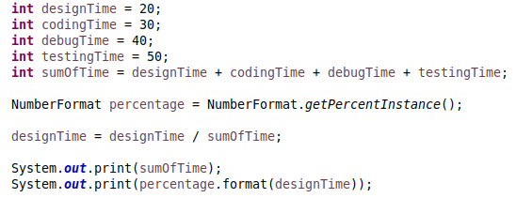
While troubleshooting the previous issue, I ended up using a `println` on the second print statement rather than the first. This made the 2 statements print on the same line which made it incredibly hard to read.

Regardless, I know know that my program is giving me the intended result after I do my real division. For some reason, the NumberFormat class thinks that 0.14 is equal to 140%, when as far as my knowledge goes, it’s actually 14%. For this reason I dropped using NumberFormat, and started using DecimalFormat to format the percentages instead.

The DecimalFormat class was throwing this error when I tried to format a double inside of my dictionary:

This is because I had renamed my dictionary keys, but didn’t do a find & replace, so all i had to do was change designTime to designing

Logic Error: I don’t know why my program is outputting the dictionary out of order. I’ve set this aside as a “later me” problem.
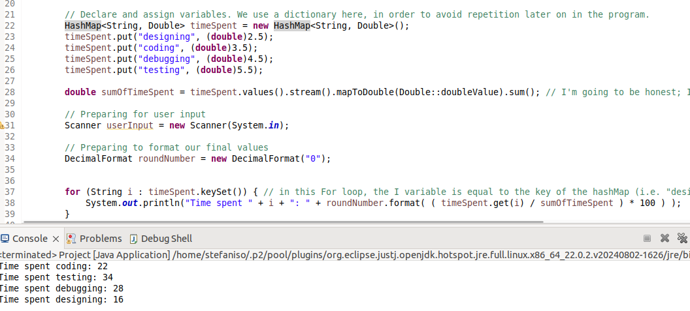

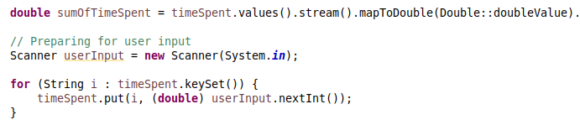
Logic error: i got the sun of values in the Dictionary before getting the dictionary values. This is only a logic error because I declare the dictionary values to be 1 as a placeholder when I create the dictionary.

